Little Brave Heart Tells His Story
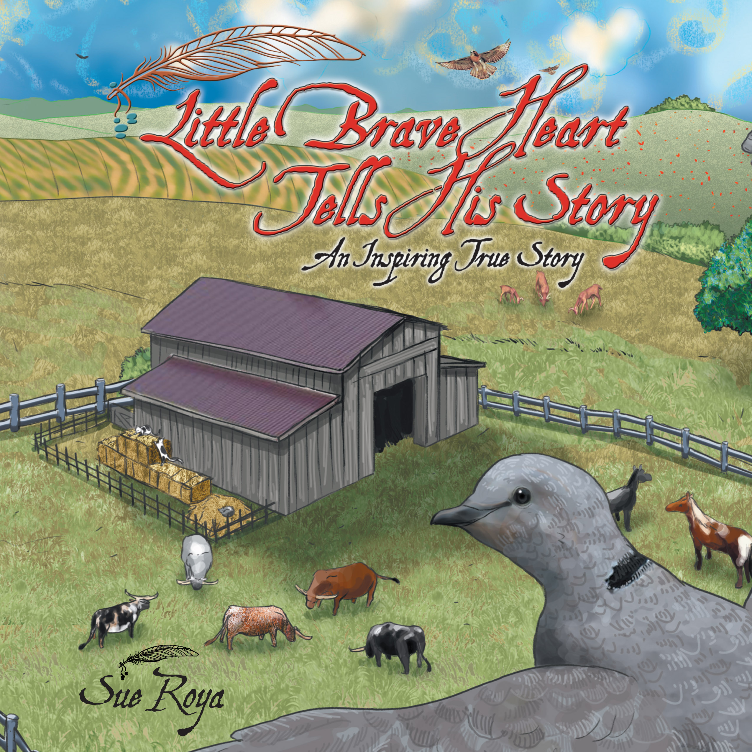
ISBNs:
Hard Cover 978-0-9987784-0-2
Soft Cover 978-0-9987784-1-9
E-book 978-0-9987784-3-3
Page Count: 34
Trim: 8.5 x 8.5
Format: Hardcover, Paperback and E-book
Price: HC $19.99, SC $9.99 E $4.99
Publish Date: Second edition 03/01/2017
Subject: Self- esteem, Motivational
Publisher: Simpatico Press
Library of Congress Control Number: 2015913902
Available from: Overdrive, Ingram Wholesaler
Sales, PR and Marketing Contact: Sue Roya
sue@sueroya.com
sueroya.com

P.O. Box 192 Los Alamos, CA 93440
Simpaticopress.com
An Inspiring True Story
by Sue Roya

About the Book

Little did this dove know, as he took his morning flight, something would hit him in mid-air so hard he would fall out of the sky into a muddy horse corral…terrified and unable to move. Luckily, he was noticed by a horseshoer with a great big mustache who gently picked him up and took him home for help.
This book will fill the reader with hope, compassion and belief in the power of love and inner-strength as Little Brave Heart shares his story of his life changing experience.

About the Author

Sue Roya, born in Niagara Falls, New York, moved to the Southwest at the age of six where she was raised for most of her adolescent years. She has lived on the Central Coast of California all her adult life, where she has enjoyed raising her family, breeding and showing Paint Horses, co-starred on their TV show, Cowboy Flavor, with her husband Billy and currently manages their internationally known catering business, Cowboy Flavor. Her experience with helping injured and homeless animals, both wild and domestic, has led her to tell their amazing stories. Sue is a member of the Society of Children’s Book Writers and Illustrators and the ASPCA.

Comp Titles:

- Saving Simon, How a Rescue Donkey Taught Me The Meaning Of
Compassion by Jon Katz ISBN: 9781410473059
- Two Dogs and a Parrot by Joan Chittister ISBN: 9781629190068
- Dillie the Deer a True Story of Love, Healing and Family by Melanie Butera
and Diane Reverand ISBN: 9781942872108
- I Am On My Way To A Happy Life by Deepak Chopra ISBN: 9781401925758
- Venus a Diary of a Puppy and Her Angel By Diana Cooper
ISBN: 9781781803851

Marketing Plans:

- Bloggers
- Reviews
- Events
- Story Times

